Enterprise Infrastructure and Networks – IT-520-A

Mallika Regulla

Marymount University

Terminal IP address: 10.0.0.108

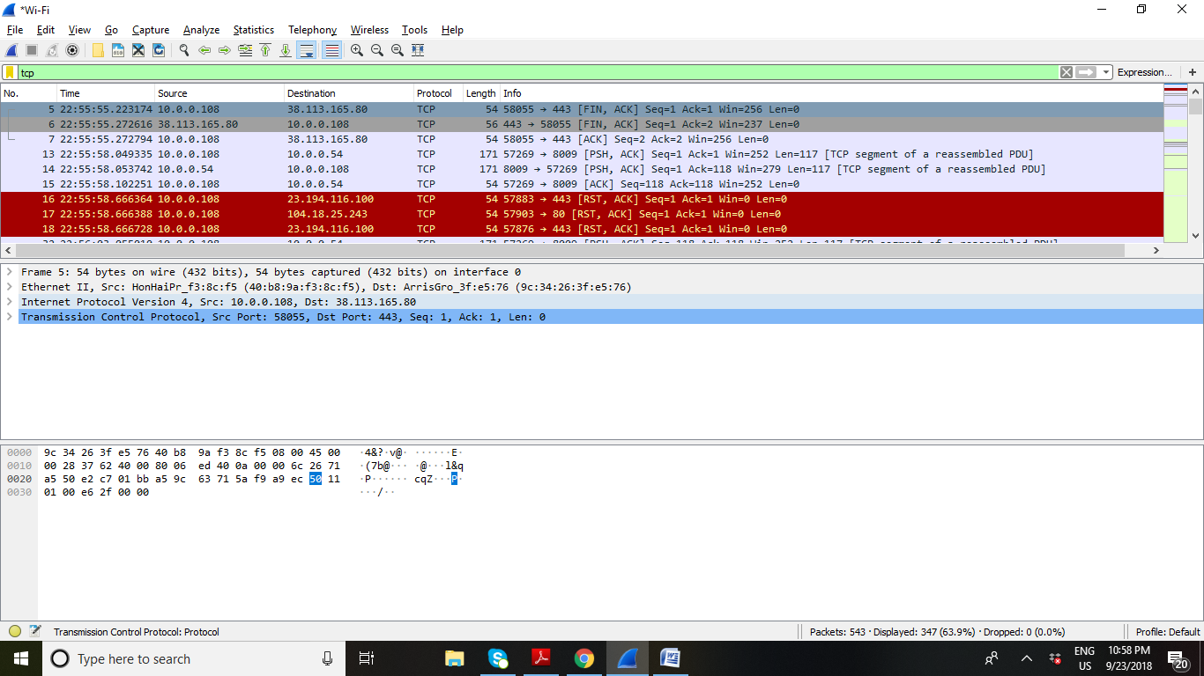

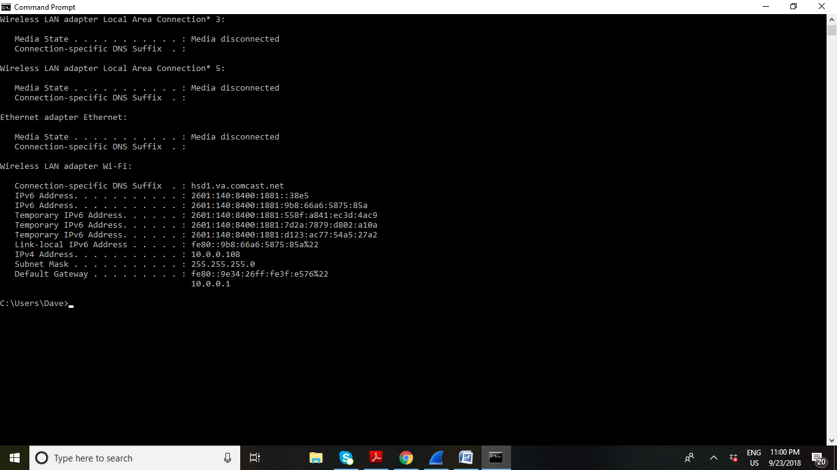

Q1: TCP port of my computer is 58173

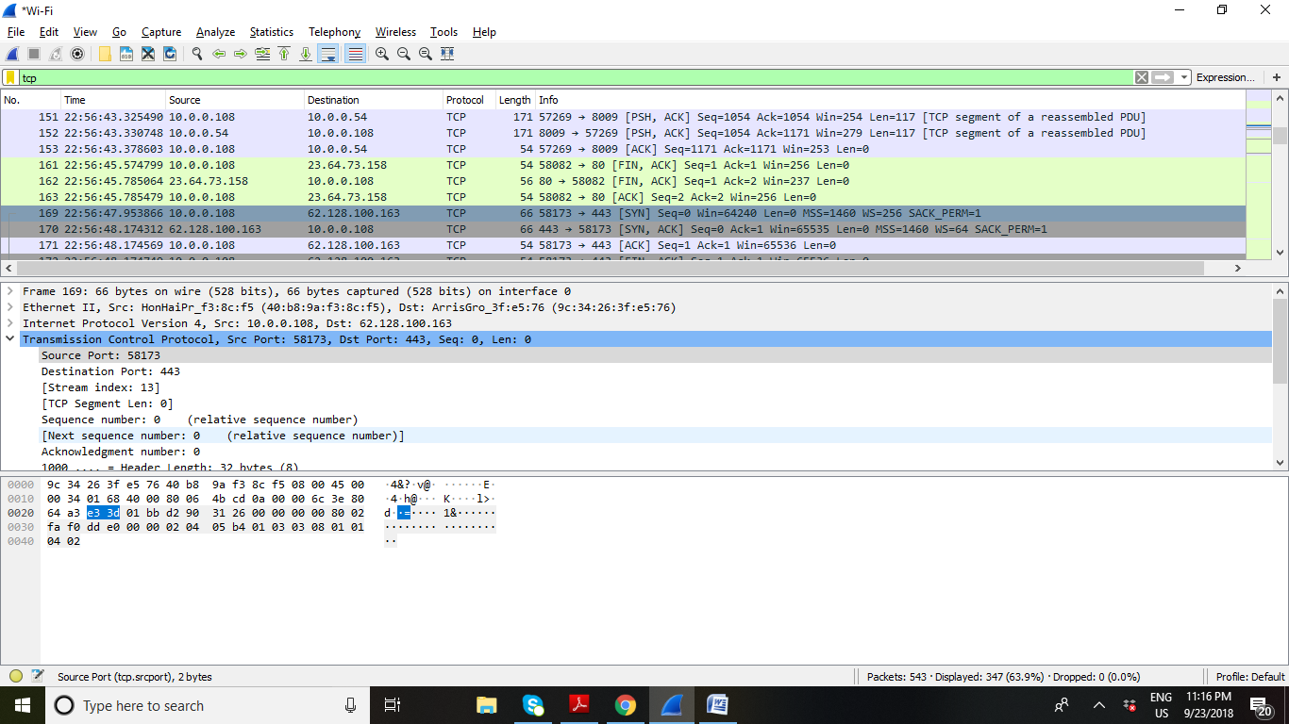

Q2: Port used by gaia.cs.umass.edu is 443

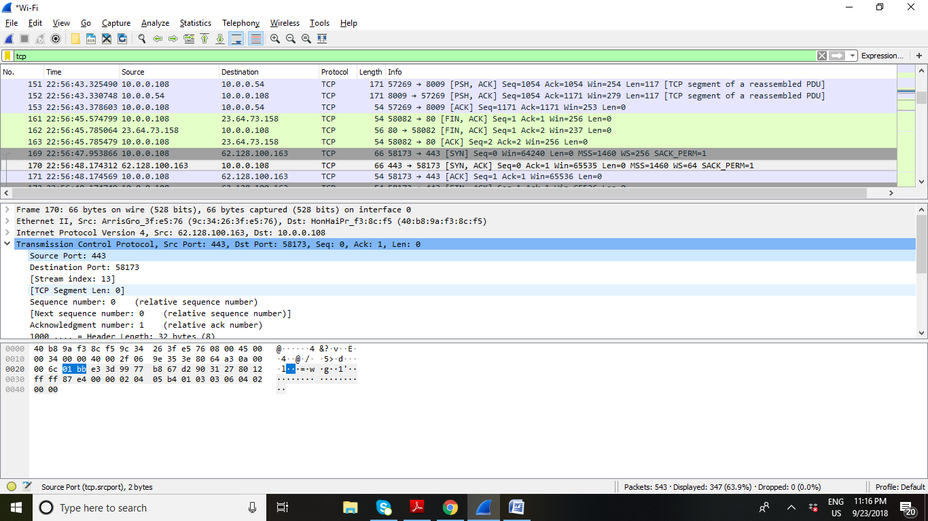

Q3: Sequence number is 0

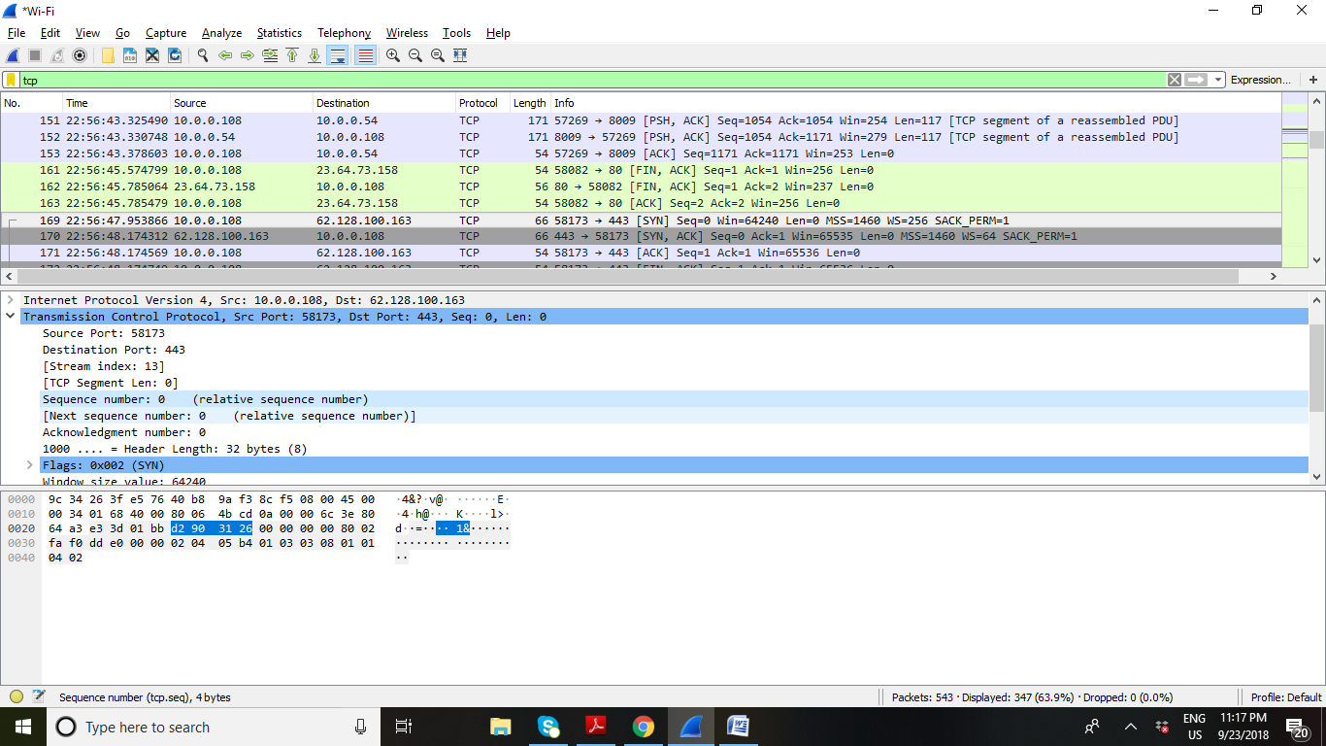

The below screenshot showing syn flag set to 1 proves this is SYN

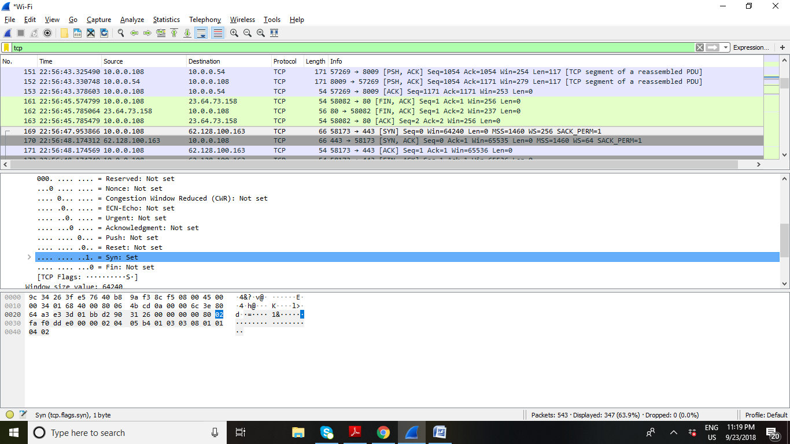

Q4: Sequence number is SYN ACK is 0

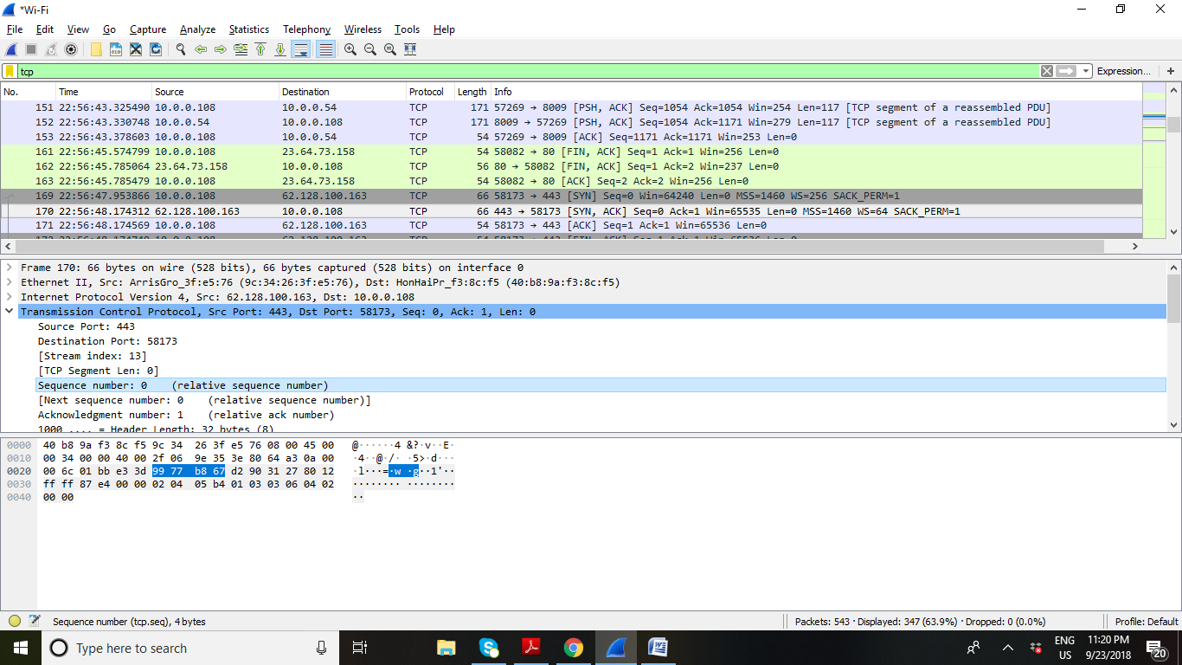

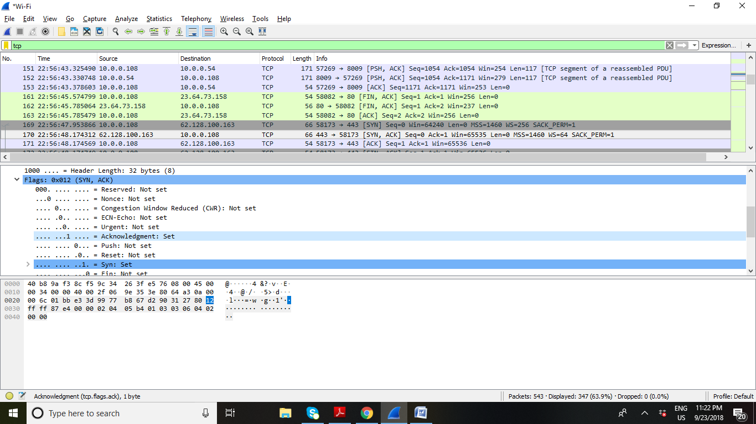

Q5: The sequence number of TCP segment with POST command is 1

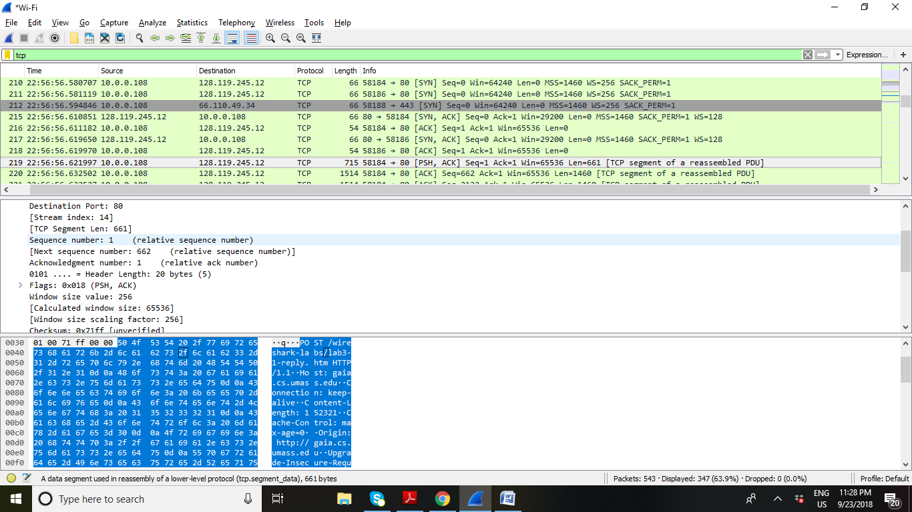

HTTP OK message:



